Script for Design Pattern
Design Pattern
Screen 10: Prerequisites, topics and exercises (see ADT script)
Text Display
Prerequisite : Knowledge of any object oriented programming language and UML class diagrams
Topics : list all the topics
Exercises : pointers to all the exercises
You will not be graded on any of these exercises until you get to the end of chapter quizzes. However, it’s extremely important that you attempt all the exercises for your own benefits as part of the learning process. Please don’t be discouraged if you are not able to get the correct answer in one go. In fact mistakes will help you learn. You will however be evaluated on attempting each of these exercises.
While rest of the exercises are important for course evaluation and self evaluation, the end of chapter quizzes will be used fully to determine your grade.
Screen 20 : The practical payoff of Design Patterns
Graphics
Imagine yourself as a Software Engineer. Suppose a user comes to you with a problem.
I want to a program that lets me see my data as either a spreadsheet and graphical representations. I know spreadsheet programs can do this much, but I need something more dynamic. When the data changes, I want both representations to be updated, too.
I’d also like to allow for other ways of viewing my data. Could I enable/disable which views get updated?
Can you come up with something cool like this?

Give a graphical representation of this text box (showing colorful graphs and excel spreadsheet screen shots)


Sure, I already see a way to solve this problem. Since this is a graphical user interface we are talking about, we’ll start by applying the Model View Controller (MVC) design pattern. The model will contain the data and there will be a source for multiple views. Views will be listening to model for changes (Observer / Observable) to maintain consistency. Tthe controller will make changes directly to the model, which if accepted, will propagate to the views. In this way, we will be able to decouple views and model and can create new views for a model easily withour rewriting it.
Uh, that’s an interesting problem. Let me see… Can I get back to you in a few days?

This one’s
a doozy!

I like someone who knows his stuff!




Narration text and Voice-over (of instructor):
Read the text part of the above graphics.

[Suggestion: Let the learner decide which software engineer
is more valuable to his clients, before bringing up the happy boss, then let the TA be Feedback to the “Correct” answer]
narration text and Voice-over and (of TA):
Wouldn’t you want to be that kind of software engineer who can solve problems by applying a tried and true design pattern, rather than hacking in the dark?

A design pattern describes a recurring, general solution to various problems, in a way that many software engineers can use.

Screen 30 : Reuse as a Motivation for Design Patterns

Graphics
“ Design Pattern” [words and/or a
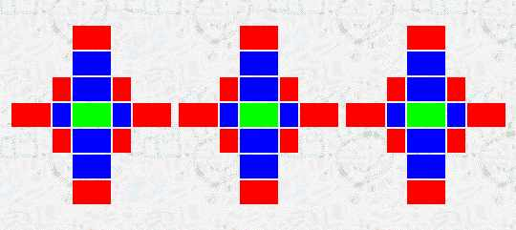
graphic? How about a Leonardo
da Vinci drawing?]

Direction
The above graphics appears in the middle of the screen. Pause for 1 sec and slowly moves up. [Motion might not apply in the case of a Da Vinci graphic—maybe a fade in?]
Text Display
- Motivation for Patterns
  - Developing complex software from scratch is hard.
  - Developing reusable software is even harder.
  - Proven solutions may include patterns that could solve other problems.

A design pattern is "a description of a solution to a general problem that is customizable in various contexts."

Voice-over (of Professor)
Motivation for Patterns. <PAUSE>
An experienced practitioner knows that development of complex software system from scratch is hard. But practitioners also know that developing reusable software is even harder, because other developers have to understand how to reuse it. Still, proven solutions may include patterns that could solve other problems. Why keep re-inventing the wheel? How can we share our knowledge about recurring solutions to software problems? A design pattern is a description of a solution to a general problem that is easily customizable in various particular contexts.

Direction
Synchronize “motivations for graphics” with corresponding lines in the voice-over.

Screen 40 : Design Patterns in buildings and software architecture

Graphics
- [How about a graphic of a blueprint, then a building in progress?]
DONE

What is a Design Pattern?

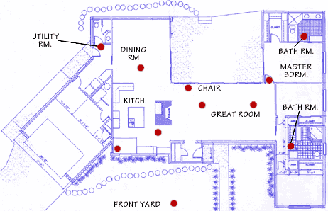


Voice-over of TA
We all talk about the way we do things in our everyday work, hobbies and home life and recognize repeating patterns all the time.
NEW ADDITION
- Sticky buns are like dinner rolls, but I add brown sugar and nut filling to them.

- This end table is constructed like that one, but in this one, the doors
replace drawers.

We see the same thing in programming, when we tell a colleague how we accomplished a tricky bit of programming so he doesn’t have to recreate it from scratch. We simply recognize effective ways for objects to communicate while maintaining their own separate existences.

A Design Pattern is thus a generalized description of the design of a certain type of a program. The designer fills in details to customize the pattern to a particular programming problem.

Narration text and Voiceover (of Professor):
Christopher Alexander pioneered the idea of design patterns
when he observed,

“Each pattern describes a problem which occurs over and over again in our environment, and then describes the core of the solution to that problem, in such a way that you can use this solution a million times over, without ever doing it the same way twice.”

Actually, Christopher Alexander was an architect. Even though he was talking about patterns in buildings and towns, software engineers have recognized that what he says is also true about software. Indeed, there is now much interest in the architecture of complex software systems.

TA voiceover: Software Architecture might be a good topic for further research. You might want to explore this trend on the web or with the hot topics engine. Click on Explore and select hot topics to do that.

Direction :
Make the Explore button to “blink” thereby drawing the user’s attention to it.

Screen 50 : A bitmap design pattern

Text Display
Consider a graphical bitmap class “Bitmap”. Suppose you want to support a variety of graphics file formats (GIF, JPG, BMP etc.). One approach would be to add a member function to Bitmap for each file type:

Note to Soma: Because we’ll be introducing Java in the multimedia, I’d rather you used Java instead of C++--though this may not be a big deal.
DONE
You also need to distinguish code from narration text (your instructions below literally imply that the voice-over should narrate the code!).

public abstract class Bitmap extends JApplet
{
public void ReadBMP(String filename);
public void ReadJPGnst (String filename);
public void ReadGIFnst (String filename);
….
};

Drawbacks in this method :
- As the number of supported file formats increase the Bitmap interface becomes increasingly cluttered.
- Supporting new file formats are difficult and undesirable, as it requires modification of existing Bitmap class every time.

Suppose you want Bitmap to support an application specific file format. Modifying Bitmap class in that case is not advisable in that case.

Voice-over
Repeat above text (and not the code). Synchronize display of text with voice-over.

Text Display & Graphics
A Better Solution :
Separate file parsing from Bitmap class by defining second class hierarchy, BitmapBuilder.


public class BitmapBuilder
{
public abstract void ReadFromFile(Bitmap rr, String filename);
};

Now, to support new file formats, you just need to inherit from BitmapBuilder and implement ReadFromFile() member. Thus, JPGBuilder reads JPG files, BMPBuilder reads BMP files. Thus the Bitmap interface is left untouched all along.

This concept of separating class interface from initialization interface is the Builder Design Pattern.

UML diagram for Builder Pattern
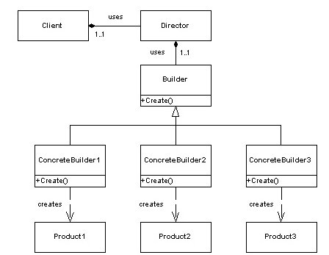

Voice-over of professor
Repeat above text (and not the code or the diagram). Synchronize display of text with voice-over.

Voice-over of student2
But, isn’t this what Java does – separating data from display methods?

Voice-over of professor
Yes, you are right. Java is thus the ideal language to implement Builder patterns.

Voice-over of Student3
I don’t understand. Does that mean it is not possible to implement Builder Pattern using any other programming languages?

Voice-over of professor
That’s not true. You can use any programming language to implement Builder pattern, however, Java is on of the few languages where you can cleanly separate the data from the display methods into simple objects.
VERY GOOD – need to design this exercise
Note to Soma: is there a name for the above pattern? If so, mention it here.
Also, it might be desirable to show this pattern visually, using UML notation. (I think we can assume classes, inheritance and UML class diagrams as prerequisite for this lesson.)
You can find UML notation for design patterns in various places, including the web. Take a look at http://rampages.onramp.net/~huston/dp/patterns.html.
A possible exercise: given the UML class diagram for this pattern, have the user instantiate it for this example, by dragging the specific classes onto the pattern diagram.

Screen 70 : Design patterns and the software development process
Text Display:
Note to Soma: is there a pictorial graphic or animation for this screen? How about a UML diagram of a pattern (say for the pattern discussed in the previous screen(s)? Better yet, how about animating such a diagram to show the dynamic structure? A diagram can make it easier to visualize the static structure of a pattern discussed in the following narration text; then animating it can make it easier to visualize the corresponding dynamic structures. On the other hand, I’m not completely persuaded that of the importance of this material at this point. Does it really belong here?

Narration text:
Patterns capture the static and dynamic structures and collaborations of successful solutions to problems that arise when building applications in a particular domain.
Reusing design patterns can improve software quality and reduce development time.
Note, a pattern is not an implementation.
Rather, it describes when, why, and how to go about creating an implementation.
Graphics
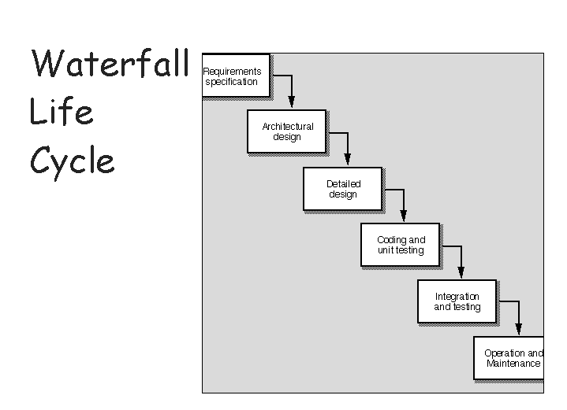
design and code are easier to understand
Simplify testing
Provide high quality solutions
Provides reusable templates for solving problems
Help analysts to understand problem

Benefits of design patterns

Voice-over
As Bruce Eckel notes, design patterns aren’t really tied to the realm of design; <PAUSE>
Patterns stand apart from traditional stages of analysis, design and implementation. A pattern embodies a complete idea within a program, so it can appear at the analysis or high-level design phase, even though a pattern has a direct implementation in code.

Effective uses of design patterns have benefits throughout the software development life cycle. They can help analysts understand new problems, by recognizing similarities to well known patterns. They can help designers, by providing reusable templates mapping problems to solutions. They benefit implementation by providing well-known, high-quality solutions. Many design patterns have already been implemented as code in libraries, such as the Java Development Kit. And design patterns enhance maintenance, by making design notes and code details easier to understand.

Direction
D

O

N

E

You can show the stages and corresponding benefits incrementally (maybe animate), while the narrator is discussing them

Note to Soma: I think the following point, from my lecture notes (and Bruce Eckel) could go about here, or perhaps in a different screen:
As Bruce Eckel notes, design patterns aren’t really tied to the realm of design;
Patterns stand apart from traditional stages of analysis, design and implementation
Instead, a pattern embodies a complete idea within a program,
so it can appear at the analysis or high-level design phase, even though a pattern
has a direct implementation in code.

A possible graphic for the above narration might be a picture of the software development process, perhaps a waterfall, with arrows pointing out how design patterns can effect different stages:
Stage Benefits of design patterns
analysis ← help analysts understand problems
design ← provide reusable templates for solving problems
implementation ←provide high-quality solutions
testing ← simplify testing
maintenance ← design and code are easier to understand

You can show the stages and corresponding benefits incrementally, while the narrator is discussing them, e.g.:
D

O

N

E
Effective use of design patterns have benefits throughout the software development life cycle. They can help analysts understand new problems, by recognizing similarities to well known patterns. They can help designers, by providing reusable templates mapping problems to solutions. They benefit implementation by providing well-known, high-quality solutions. Many design patterns have already been implemented as code in libraries, such as the Java Development Kit. And design patterns enhance maintenance, by making design notes and code details easier to understand.

Voice-over
Repeat above text. Synchronize display of text with voice-over.
Remember, a pattern is not an implementation. It describes when, why, and how to go about creating an implementation.

Screen 80 : Four parts of design patterns

Text Display

4 essential elements of pattern

- pattern name : is a handle to describe a design problem, its solutions and consequences in a word or two.

- problem : describes when to apply a pattern

- consequences (forces or tradeoffs) : are the results and trade offs of applying the pattern.

- solution (context) : is an abstract description of a design problem with general arrangements of elements to solve it. The solution does not however describe a particular concrete design or implementation.

Voice-over
The Gang of Four developed a convention for describing design patterns, with four parts:
First, the name of the pattern begins the pattern.
Second comes a statement of the problem the pattern solves.
Third is a discussion of the constraints (or “forces”) on the problem comes next. This section is meant to bring across why the problem is hard, and may discuss alternative solutions that have been examined and rejected.
Finally, the pattern contains a description of the solution to the problem (often in the form of an example or template).

Screen 90 : Quiz reviewing purpose of design patterns

Exercise
Which of the followings is a characteristic of design PATTERN (select whchever applicable):

- Design Pattern embodies a complete idea within a program.

- Design Pattern is an actual implementation of a problem.

- A Design Pattern can encapsulate actions or processes.

- Design Pattern and Object Oriented Programming are similar in the sense they both try “to separate the things that change from the things that remain the same.”

Direction
Answers (a), (c) and (d) are correct. A design pattern embodies a complete idea within a program so that it can appear at the analysis phase of design. It also encapsulates actions or processes in order to describe how to go about creating an implementation. It’s interesting to note that both Design pattern and OOP separates the things that change from the things that remain the same.

Answer (b) is incorrect as Design Pattern only describes when, why and how to go about creating an implementation. A Design pattern is NOT an implementation. Many libraries such as JDK has already got some implementations of Design Pattern in the form of code even though Design Pattern itself is not an implementation.

If answers are all correct display message “CORRECT” Otherwise show the correct answers. Explain why it is correct and why it is a wrong answer.

Screen 100 : Three Categories of Design Patterns
Graphics

Hides details about different ways of instantiating objects
Hides details of recurring behaviors and processes
Hides details about how objects connect to each other

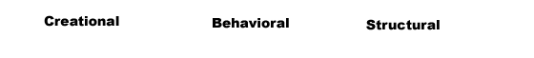

Direction

Note to Soma: how about a tree diagram, with “Design Patterns” as the root, each of the above as a branch, and the particular patterns as leaves? You could animate the tree by having the branches synchronize during the corresponding voice-over. Let the user select a branch, causing the purpose and leaves to appear. E.g., when user clicks on “Creational”, show “hide details about different ways of instantiating objects” then after a couple of seconds, grow branches for Singleton, FactoryMethod, Prototype, …
DONE

Voice-over
The Gang of Four have distinguished three major categories of design pattern: creational, structural and behavioral. We’ll use these categories to lay out a map of the territory we are about to explore. Click on each of the three categories to see the purpose and examples.

Screen 110 : Creational Patterns

Graphics

Hides details about different ways of instantiating objects
Hides details of recurring behaviors and processes
Hides details about how objects connect to each other



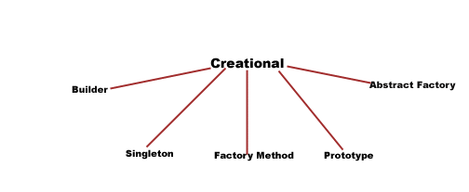
Factory for building complex objects incrementally
Factory for a singular sole instance
Factory for method in a derived class creating associates
Factory for cloning new instances from a prototype
Factory for building related objects

Direction
Start the screen with the tree from the previous screen. After a second, a magnifying glass appears over the Creational Patterns part, causing it to expand (and the rest of the tree to disappear), so that the user now sees all five patterns.

Voice-over
Creational patterns encapsulate the details of object creation.
Factory Method, Abstract Factory, Builder, Prototype and Singleton represent different ways of instantiating objects.
Click on each pattern to learn a bit about it.

Exercise
Click on each node to explore each pattern.

Direction
When the user clicks on a pattern, {a brief description and a UML diagram – not sure} appears?

Screen 120 : Structural Patterns
Many fine-grained objects can be shared efficiently
Graphics
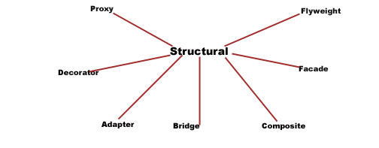
Translator adapts a server interface for a client
Abstraction for binding one of many implementations
Structure for building recursive aggregations
Simplifies the interface for a subsystem
One object approximates another
Extends an object transparently

Voice-over
You use a structural pattern to hide the details of an object relationship.
For example, …
Structural patterns include Adapter, Bridge, Composite, Decorator, Façade, Flyweight and Proxy.

Direction
Start the screen with the basic tree. After a second, a magnifying glass appears over the Structural Patterns part, causing it to expand (and the rest of the tree to disappear), so that the user now sees all seven patterns.

Exercise
Click on each node to explore each pattern.

Direction
When the user clicks on a pattern, {a brief description and a UML diagram – not sure} appears?

Screen 120 : Behavioral Patterns
Graphics
Abstraction for selecting one of many algorithms

Dependents update automatically when a subject changes
Object whose behavior depends on its state
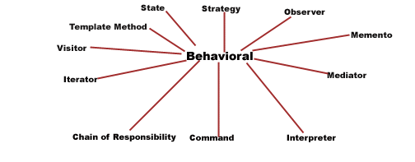
Request delegated to the responsible service provider
Request as first-class object
Language interpreter for a small grammar
Coordinates interaction between its associates
Snapshot captures and restores object state privately
Algorithm with some steps supplied from a derived class
Operations applied to elements of an heterogenous
Object structure.

Aggregate elements are accessed sequentially

Voice-over
You use behavioral patterns to hide details of an action or process. For example, Iterator lets you write generic code that performs an operation on all or some subset of the elements in a collection—while ignoring the collection’s implementation details.
Besides Iterator, Chain of Responsibility, Command, Interpreter, Mediator, Memento, Observer, State, Strategy, Template Method and Visitor are behavioral patterns.

Direction
Start the screen with the basic tree diagram. After a second, a magnifying glass appears over the Behavioral Patterns part, causing it to expand (and the rest of the tree to disappear), so that the user now sees all eleven patterns.

Exercise
Click on each node to explore each pattern.

Direction
When the user clicks on a pattern, {a brief description and a UML diagram – not sure} appears?

Screen 130 : Observer Pattern

Text Display
Observer Pattern
Class Observable keeps track of everybody who wants to be informed of a change.
Class Observer informs all objects monitored by Observable class to update themselves.

4 essential elements of Observer Pattern :

- Pattern name : Observer

- Problem : To maintain consistency between related objects, whose states may be changing independently.

- Forces :
- To develop the objects separately, to minimize coupling (what they know about each other).
- Increase reuse (using one without the other).

There may be several observers for each subject, with the precise configuration unknown at compile-time.

- Solution: To develop a method so that all object monitored can be updated automatically.

Exercise
Which type of pattern is ” Observer”?

Direction
Make the 3 categories “Creational”, “Behavioral” and “Structural” as clickable nodes.

Voice-over
Let's now talk about specific pattern. Of the three categories--creational, structural or behavior, which type of pattern is Observer? Click on one. [Make this an interactive exercise, showing the three categories as a tree with clickable nodes.]

Feedback

Class Observer is a behavioral pattern.
This is an inbuilt design pattern in JAVA. Observer Pattern defines a one-to-many dependency between objects so that when one object changes state, all its dependents are notified and updated automatically.

Graphics

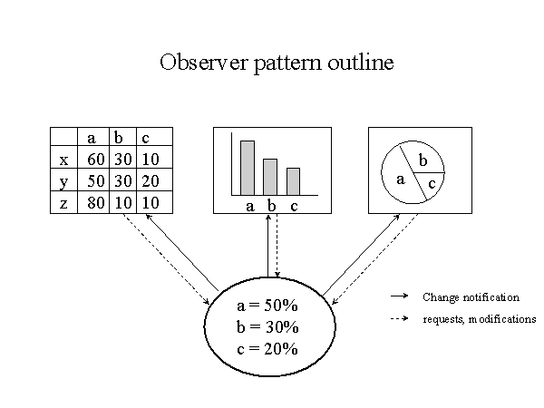
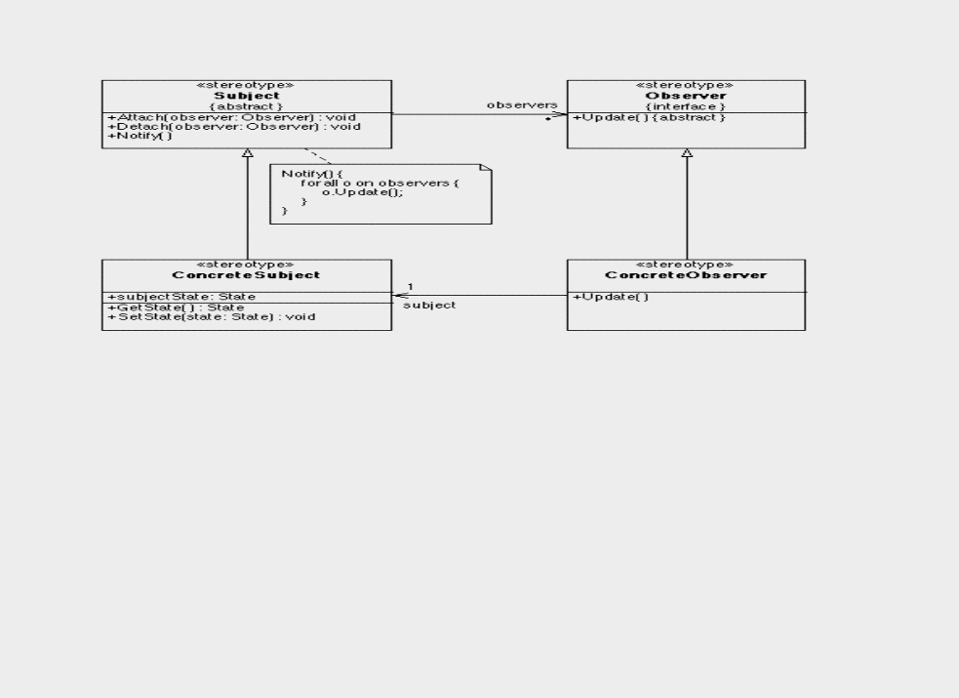

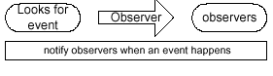
Voice-over
You start by modeling the "independent" functionality with a "subject" abstraction and the "dependent" functionality with "observer" hierarchy .Note that the Subject is coupled only to the Observer base class. Observers register themselves with the Subject. The Subject broadcasts events to all registered Observers. The Observers "pull" the information they need from the Subject. And finally, the Client configures the number and type of Observers.

Screen 140 : Abstract Factory Pattern
Text Display
ABSTRACT FACTORY – a creational pattern

4 essential elements of Abstract Factory:

- Pattern name: Abstract Factory
- Problem: To construct an instance of one of a suite of classes, deciding between the classes at the time of instantiation.

- Forces: To avoid duplicating the decision making everywhere an instance is created

  - Solution: A mechanism for creating instances of related classes without necessarily knowing which will be instantiated.

Voice-over
Abstract Factory is a Creational Pattern. <Read above text>

Graphics:
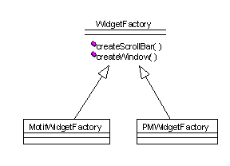

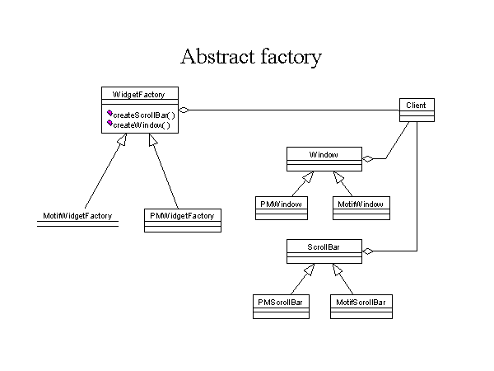
Voice-Over
A factory class exists just to help create instances of other classes. Factories often have methods that produce instances of several related classes, but all in a compatible way. Factories
should themselves be defined via interfaces, so the client need not know which particular factory object it is using. Ideally, all such matters can be reduced to a single call to construct the
appropriate 'master' factory in a client application. Among the most popular examples of factories are UI toolkits that are designed to run on different windowing systems.

Text Display
There might be interfaces for things like:

interface ScrollBar { ... }
interface MenuBar { ... }
...

And associated classes implementing them on different windowing systems:

class MotifScrollBar implements ScrollBar { ... }
class Win95ScrollBar implements ScrollBar { ... }
...

And a factory interface that also doesn't commit to representation:

interface Factory {
public abstract ScrollBar newScrollBar();
public abstract MenuBar newMenuBar();
...
}

But implementation classes that do:

class MotifFactory implements Factory {
public ScrollBar newScrollBar() { return new MotifScrollBar(...); }
...
}

Finally, to get an application up and running on different systems, only one bit of implementation-dependent code is required:

class App {
public static void main(String args[]) {

Factory wf = null;
if (args[0].equals("Motif"))
wf = new MotifFactory();
else ...

startApp(wf);
}
}

Voice-over
All other objects can construct widgets using the factory passed around or kept in a central data structure, never knowing or caring what windowing system they happen to be running
on.

The Java AWT uses a strategy that is similar in concept but different in detail for achieving implementation independence, via a set of 'peer' implementation classes that are specialized
for the platform that the Java session is being run on, and instantiated when user-level AWT objects are constructed.
Screen 150 : Design Patterns in Java
Text Display & Graphics
Click on each of the patterns below to learn more about it.
- Patterns in java.io:
Decorator
In a text editor various decorators can add properties to a bare text display. In this example scroll bars are added to the text frame and then a visual border is added around the scroll bar.
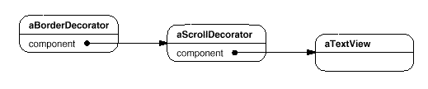
For this to work, all the decorators must define the same protocol as the text view and perhaps be the same type as is. The simplest way to do that is to
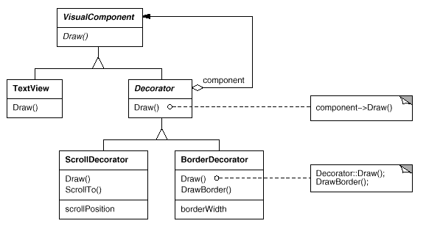

Tha java.io streams library allows you to read and write from arbitrary streams of bytes. It heavily uses the Decorator pattern (this pattern adds responsibility to an object without it knowing about it) to achieve what Unix programmers do with pipes and filters.
- Patterns in java.util:
Observer
Example: Observing a Car A car object supports two states, speed and direction. A driver task independently updates the car state once a second. We wish to monitor the car and display its state variables in several different ways in a GUI.
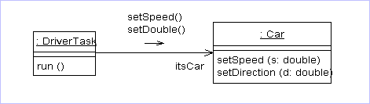

We solve the problems four different ways, demonstrating four variations on the Observer pattern.
Java Model Observer Class Diagram
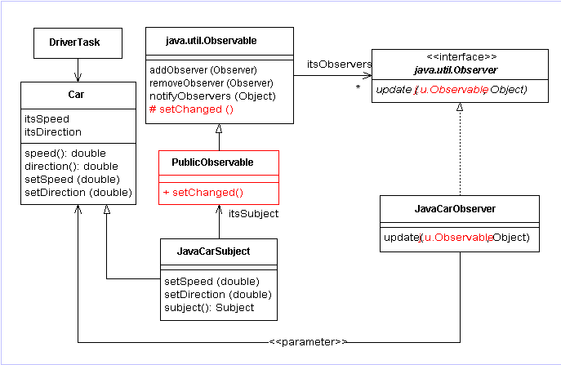
- Patterns in java.awt:
  - Composite
A generic Abstract Window Toolkit(AWT) container object is a component that can contain other AWT components.

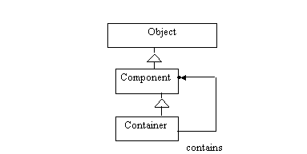 Container represents the parent object in visual component hierarchy. It is a visual component that contains sub-components and delegates some its functionality to its children. Component has characteristics of child object in visual components tree structure. May inherit some characteristics from its parent.

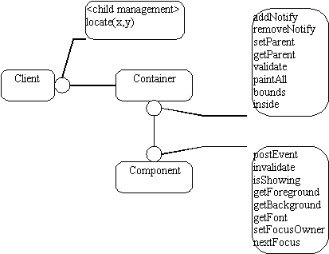

This scenario illustrates how the component inherits its font from its parent when not explicitly set.

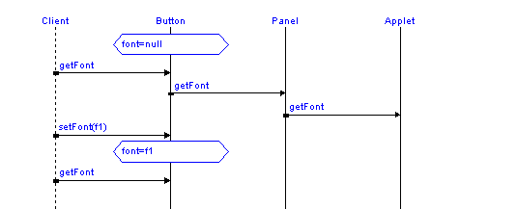

The following scenario illustrates how the validation is propagated down the containment hierarchy and how the validation causes the component being laid out.
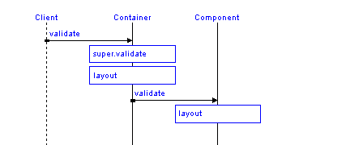

  - Chain of Responsibility (COR)
The intent is to avoid coupling the sender of a request to its receiver by giving more than one object a chance to handle the request. Chain the receiving objects and pass the request along the chain until an object handles it.
While COR pattern involves traversing up a list or a tree from more specific handlers to more general handlers, traversing down a tree is not the COR pattern; it is the Composite pattern!
The above diagram shows the use of Chain of Responsibility pattern in event handling, getFont, getBackgroundColor, methods.
  - Strategy
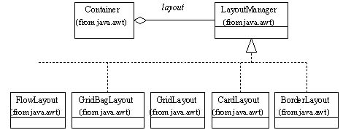
LayoutManagers are strategy objects. Strategy Objects define a family of algorithms, encapsulate each one, and make them interchangeable. Strategy lets the algorithm vary independently from the clients that use it.
  - Bridge
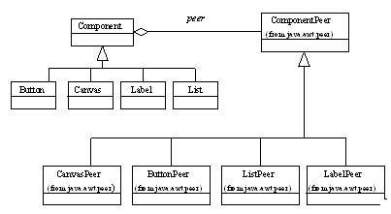
The relationships between the components and peers implement the Bridge Pattern. Bridge Pattern decouples an abstraction from its implementation so that the two can vary independently. The structure is very similar to an Abstract Factory, only instead of being used to create things, the dual class hierarchies are used to perform things, while allowing the interface hierarchy and the implementation hierarchy to vary independently.
  - Abstract Factory
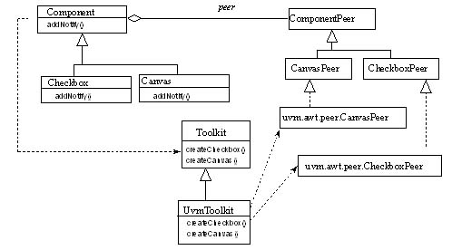
Classes like "Panel" and "Component" are actually abstract classes, and Java has "peer components" for each class that are specific to the windowing environment in which it runs.

This is the problem that an Abstract Factory solves. Each widget has its own class hierarchy with the abstract class at the root, and the concrete platform-specific implementations as subclasses. Suppose you have abstract classes corresponding to a GUI Window, and a Panel, and a TextEntry field, and a ScrolledText field, and any other number of GUI widgets. If the
program needs to run on multiple platforms, then you might need a platform-specific implementation for each widget. Then you create an additional hierarchy of factory objects. The "Abstract Factory" class is at the root of this factory hierarchy. Concrete subclasses of this abstract factory would be classes like MSWidgetFactory, MacWidgetFactory, and MotifWidgetFactory.
  - Singleton
Sometimes the nature of the problem being solved requires that at most one instance of a particular class is created. This is done by making the class constructor non-public. Then the class has a static method that returns a reference to the lone instance of the class. This static method is responsible for initially creating the singleton instance if it doesn't already exist.
Example : All panels use a common instance of FlowLayout.
Java introduces some special GOTCHAs when trying to implement a Singleton. If the only reference to a class instance is from the class itself, the JVM thinks it is okay to unload the class (which causes it to be garbage collected). If it is accessed again later, than the JVM will reload it and recreate the singleton object. If it is important that the constructor and finalize methods never execute more than once during the lifetime of the application, then this poses a problem. One-way to avoid it is to register singleton instances in some system wide table so that it is protected from garbage collection. Consider using latent threads: Create a thread for each singleton at the time that the singleton instance is created. Do not schedule the thread to run, this is not the purpose of the thread. The mere existence of the thread will protect the singleton. Also consider using a registry class, which maintains a collection of the singleton instances. Create one latent thread for the registry instance. Both the registry and any singleton instances it has references to will be protected from garbage collection and it only uses one thread.

Voice-Over
Read above text.

Note to Soma: walk through code that demonstrates this pattern. Show it incrementally, so that the idea of decoration as adding to a base becomes clear.
It might also be desirable to supply code snippets or pointers to class descriptions for each of the patterns, and then invite the user to click on each of the pattern names to see the patterns in Java. Or is this too much work?

Direction

Show only the list of Design Patterns in Java. Allow user to click on any design pattern, one at a time to learn more about it.
Screen 160 : Exercises

Exercise
which encapsulates a command request

Suppose you have been assigned to develop a simple text editor, whose most interesting feature will be multiple undo/redo, i.e., it should be possible to undo any sequence of commands that changes the state of the text in the editor and correspondingly redo them.
Name
(It describes the design problem in a nutshell)

Problem
(It describes when to apply a pattern)

Forces
(results and trade offs of applying the pattern)

Solution
(abstract description of a design problem with general arrangements of elements to solve it)

The line-editor, loosely based on Unix ed, will have just a few commands, as described below. The emphasis is on undo rather than a full-blown editor.

The line-editor will run indefinitely, prompting the user for commands, until the user enters q. It will respond to the following commands:
r <filename> Read a file into an editing buffer.
w Write buffer back into the file (ask if no file read).
p Print the file, with line numbers.
g <line-num> Go to line-num, and print out that line.
i Insert lines before current line, up to a line with just "."
d Delete current line.
c Delete current line and insert new ones.
u Undo the previous command (that changed the buffer).
f Forward to the previous command (redo).
q Quit line-editor (ask if file has not been saved)
Undo/redo apply to commands that actually change the buffer (r, i, d, c), for up to 25 commands. If user input is unrecognizable as a command, editor will prompt for another command. The line-editor may be extensible to accommodate more such commands in future.
Explicitly represent units of work as Command objects.

Direction
Just to recapitulate, the 4 essential elements of any Pattern are Name, Problem, Forces and Solution.

Your job is to try to recognize a design pattern, if it exists, in the above problem that you have been assigned.

Try to match the different parts of the above sentences which best describes following from different parts of the above mentioned problem.

Feedback messages (voice-over of Instructor)
a)Good Job. You have just been able to identify a design pattern in the above problem. This is the Command Pattern. Command Pattern is a behavioral pattern.
Or b) Well, you seem to have a little problem in this exercise.

Choice 1:
Do you want to go back and review the material that we’ve already covered?
Choice 2:
Do you want to plough through till you get it?

Screen 170

Exercise
Chose which one of the followings can be a part of Command class: (you may have multiple things to drag)
EDIT-BUFFER, UNDO, READ, WRITE, PRINT, INSERT, DELETE, QUIT

Feedback
Edit-buffer, print and quit are wrong answers.
Undo is a partially right answer, if the user drags it to the Command class, but note that it's not a Command but a feature of Command;
read, write, insert, delete drag to ConcreteCommands, instantiating them.

Voice-over of TA
If you are not sure how to solve this exercise click on “SHOW ME” button.

Direction
If the student clicks on “SHOW ME” button on screen:
Complete the interactive exercise (step through different stages).

This should be programmed as part of pre-recorded “SHOW ME” session. Also save the same under the archive list of “Show ME” sessions for future referral.

Screen 180: Useful lore about Design Patterns

Text Display

Is a pattern a paradigm? What do you mean by paradigm here? Let's discuss this question. BTW, on this screen, all the "graphics" are text. Let's see we if we can't come up with pictures for graphics, too. E.g., for the question about rules, how about a picture of a rule?

Patterns try to describe relationships within and between the parts, not just the parts themselves.

Voice-over
The pattern approach is a paradigm only in the most abstract, almost philosophical sense of the word. The goal of most popular paradigms is to make a complex work understandable by organizing it into separable parts, each of which can be separately understood. Patterns try to describe relationships within and between the parts, not just the parts themselves. This is why patterns are truly an architectural technique, not just a divideandconquer technique.

Graphics & Text Display
Aren't patterns just rules?

A rule may be part of a pattern description, but a pattern also supplies a description of a context.

Voice-over
Rules aren't as rich as design patterns. Rules generally don't include a rationale, nor a description of context. A rule may be part of a solution in a pattern, but is neither sufficient nor necessary. Patterns aren't designed to be executed or analyzed by computers, as one might imagine to be true for rules: patterns are to be executed by architects with insight, taste, experience, and a sense of aesthetics.

Graphics & Text Display
Are patterns and idioms related?



Idioms are special kinds of patterns that are tied to a specific programming language. Patterns are more generic in that sense.

Voice-over of Professor
Jane, I am glad you’ve asked this question. Idioms are special kinds of patterns that are tied to a specific programming language. For example, C++ programmers learn idioms about when to override default constructors and assignment operators, in ways that are peculiar to the C++ language. Recasting idioms in pattern form can make them more accessible to C++ programmers.
Direction
Display text after the voice-over is over for this screen.

Note to Soma: is the following another screen, or even several more? See comments on screen structure above: break things up, use some pictorial graphics, add interactivity. You may also want to provide links to relevant sites on the web. There are plenty of good sites to be found by searching for "design patterns" using google.com or some other search engine.

Screen 190: Patterns and reuse

Text Display & Graphics

A pattern is a recurring solution to a standard problem. Design patterns focus on reuse of ‘design ideas’ rather than on reuse of components.

There is nothing new about patterns since by definition patterns capture experience. It has long been recognized that expert programmers don't think about programs in terms of low level programming language elements, but in higher-order abstractions [Adelson and Soloway][Soloway and Erlich][Curtis][Linn and Clancy]. What is new is that people are working hard to systematically document abstractions other than algorithms and data structures.

Voice-over
<read above text>

Screen 200: How and when to use Design Patterns

Text Display
How to use Patterns
Usually the pattern describes a role for an object – not a class!
- You may have to scout around the intents to find a closer match
- Page through the diagrams
- Guess and experiment!

Text Display
When to use patterns? Look for:
- Solutions to problems that recur, with slight variations.
There's no need for reuse if the problem arises in just one context.
- Solutions that require several steps.
Patterns can be overkill if solution is a simple set of instructions.
- Solutions where the solver is more interested in the existence of a solution than its complete derivation.

Remember: a pattern is like a template that can be applied in many different situations.
Voice-over
<read above text>

Note to Soma: the following material may be beyond the scope of what we need to accomplish in this lesson. I think our goal should be to help learners to begin learning how to use patterns, not create them. Let's discuss. I think the above material would make a decent conclusion, after the exercises below.

Graphics
Writing Patterns
Writing good patterns is not so easy! Patterns should not only provide facts (like a reference manual or user's guide), but should also tell a story, which captures the experience they are trying to convey.
A pattern should help its users to:
- comprehend existing systems, by documenting existing design;
- customize systems to fit user needs; and
- construct new systems, by developing new OO systems.

The process of looking for patterns to document is called pattern mining (or sometimes reverse-architecting).

Voice-overs
<REPEAT ABOVE TEXT>
Design patterns can form a shared vocabulary with which engineers can converse about design decisions.
An important feature of the design pattern format is the discussion of the "forces" or tradeoffs that each design pattern addresses and which the solution resolves. If an engineer can understand that a particular design pattern has been used as part of an OO design, he can make certain assumptions about the constraints that were placed on the design. Once the constraints are understood, he can

Screen 210: How do you know a pattern when you come across one?

Text Display & Graphics


How do I know a pattern when I come across one?



The answer is you don't always know. You may jot down the beginnings of some things you think are patterns, but it may turn out that they aren't patterns at all, or they are only pieces of patterns, or simply good principles or rules of thumb that may form part of the rationale of a particular pattern. It is important to remember that a solution in which no forces are present is not a pattern.


How do I develop an intuition to identify a pattern?
Does that mean that pattern identification is an intuitive process – if I do not have an intuition, I can never see it.

That’s not fully true, David. The best way to learn how to recognize and document useful patterns is by learning from others who have done it well! Pick up several books and articles, which describe patterns (don't choose just one) and try and see if you can recognize all the necessary pattern elements and desirable qualities that were mentioned earlier in this paper. When you see one that appeals to you, ask yourself why it is good. If you see one you don't like, try and figure out exactly what it is about the pattern that leaves you unsatisfied. Read as much as you can, and try to learn from the masters. Numerous resources for learning more about patterns are given near the end of this paper. Most importantly, be introspective about everything you read! Examine how it is meaningful to you and how it will help you accomplish future goals.

After you have been exposed to a wealth of pattern literature, choose one of the various pattern formats and see if you can flesh out some of your earlier ideas for things you thought might be patterns. If you are trying to compose a language of patterns, start by examining the forces and context of each pattern and try to identify any simple underlying principles that seem to help organize the patterns together into useful configurations.
Voce-over
Read above text.

Screen 220:

Exercise
which encapsulates a command request

Suppose you have been assigned to develop a simple text editor, whose most interesting feature will be multiple undo/redo, i.e., it should be possible to undo any sequence of commands that changes the state of the text in the editor and correspondingly redo them.
Name
(It describes the design problem in a nutshell)

Problem
(It describes when to apply a pattern)

Forces
(results and trade offs of applying the pattern)

Solution
(abstract description of a design problem with general arrangements of elements to solve it)

The line-editor, loosely based on Unix ed, will have just a few commands, as described below. The emphasis is on undo rather than a full-blown editor.

The line-editor will run indefinitely, prompting the user for commands, until the user enters q. It will respond to the following commands:
r <filename> Read a file into an editing buffer.
w Write buffer back into the file (ask if no file read).
p Print the file, with line numbers.
g <line-num> Go to line-num, and print out that line.
i Insert lines before current line, up to a line with just "."
d Delete current line.
c Delete current line and insert new ones.
u Undo the previous command (that changed the buffer).
f Forward to the previous command (redo).
q Quit line-editor (ask if file has not been saved)
Undo/redo apply to commands that actually change the buffer (r, i, d, c), for up to 25 commands. If user input is unrecognizable as a command, editor will prompt for another command. The line-editor may be extensible to accommodate more such commands in future.
Explicitly represent units of work as Command objects.

Direction
Just to recapitulate, the 4 essential elements of any Pattern are Name, Problem, Forces and Solution.

Your job is to try to recognize a design pattern, if it exists, in the above problem that you have been assigned.

Try to match the different parts of the above sentences which best describes following from different parts of the above-mentioned problem.

Feedback messages
Good Job. You have just been able to identify a design pattern in the above problem. This is the Command Pattern. Command Pattern is a behavioral pattern.

Screen 230:

Exercise
Chose which one of the followings can be a part of Command class: (you may have multiple things to drag)
EDIT-BUFFER, UNDO, READ, WRITE, PRINT, INSERT, DELETE, QUIT

Direction
Complete the interactive exercise if the student is not able to do so.

Feedback
Edit-buffer, print and quit are wrong answers.
Undo is a partially right answer, if the user drags it to the Command class, but note that it's not a Command but a feature of Command;
read, write, insert, delete drag to ConcreteCommands, instantiating them.

Screen 240: Command Pattern

Graphics
Command Pattern is a behavioral pattern.

This is how it looks like.
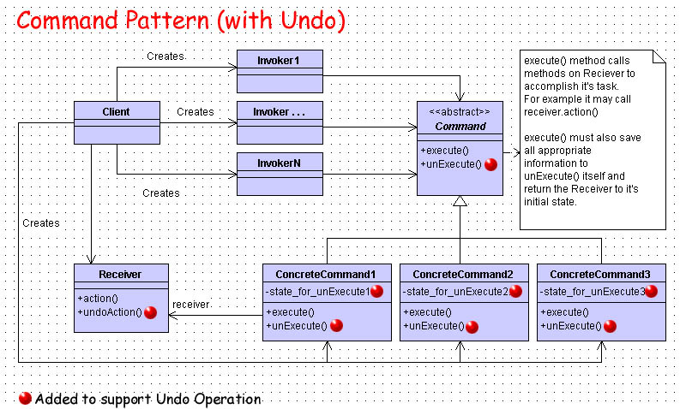

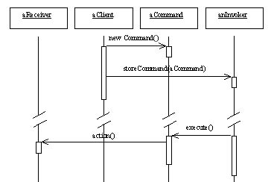

Voice-over

The Command Pattern encapsulates an action as an object. It lets you queue or delay the object actions and also supports undo. This pattern is generally used in GUI interface.

The sequence diagram shows the interactions between the objects. It illustrates how Command decouples the Invoker from the Receiver (and the request it carries out). The client creates a concrete command by parameterizing its constructor with the appropriate Receiver. Then it stores the Command in the Invoker. The Invoker calls back the concrete command, which
has the knowledge to perform the desired Action() operation.

The Invoker issues a request by calling execute on the Command object. The concrete Command object invokes operations on its Receiver to carry out the request.

The key idea here is that the concrete command registers itself with the Invoker and the Invoker calls it back, executing the
command on the Receiver.

Direction
Animate the sequence diagram and/or have the user step through the animation. Synchronize voice over with the animation while explaining what each step of sequence diagram does.

.

Screen 250: Conclusion

Graphics

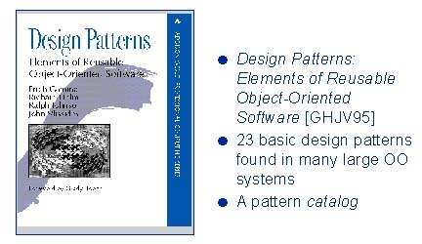

http://www.hillside.net/patterns/DPBook/DPBook.html

Close with a quiz. I can work with you on the questions. It would be good to set up a template for all the chapters hooking the end of chapter quizzes up to a database facility of some kind. Martin Herr and David Gevry might work on this.

Screen 260: End of chapter quizzes
Please note that you will be graded on these set of questions presented below.
Exercise

Identify the pattern in the following examples:
(Choose the correct answer)

- You have a Client / Server application communicating by means of Sockets. Messages are exchanged in the serialized form – say the server reads a stream of bytes. The server know what message to instantiate by reading the message header of each message. The header is typically just a few bytes and arrives first. What design pattern will you use in this case?

  - Abstract Factory Design Pattern
  - Command Design Pattern
  - Observer Design Pattern

- Suppose you are writing a multi-lingual natural language processing application. The application bootstraps by reading dynamic derivation rules and dictionary of legal words. Then the application is given the file, which contains sentences and it is expected to label the parts of speech in every sentence.

Identify which of the followings (chose multiple answers if applicable) could be possible classes for the above application without assuming anything beyond what has been specified.

  - Natural language Application
  - Derivation Rule
  - Dictionary of Rules
  - Legal words
  - Parts of Speech
  - Word
  - Sentence
  - File

- Refer exercise (2) above. Which design pattern can be used to interact between the Parser and the Extractor in the above example?

  - Abstract Factory Design Pattern
  - Command Design Pattern
  - Observer / Observable Design Pattern
Indicate whether the following sentence is True or False.

4) Design Pattern is all about designs that can be encoded in classes and reused as is.

